2. Property Buying & Rental System
Aim: To create a cloud-based Property Buying and Rental System using Zoho Creator to manage property details, buying, and rental information in Chennai.
Procedure:
- Log in to Zoho Creator and create a new application.
- Create a form named Property Details.
- Add fields such as Property Type, Buy/Rent, Area, Place, Price Range, Property Value, and Rental Agreement.
- Enter property details and save the records.
- View and manage the property information online.
Implementation
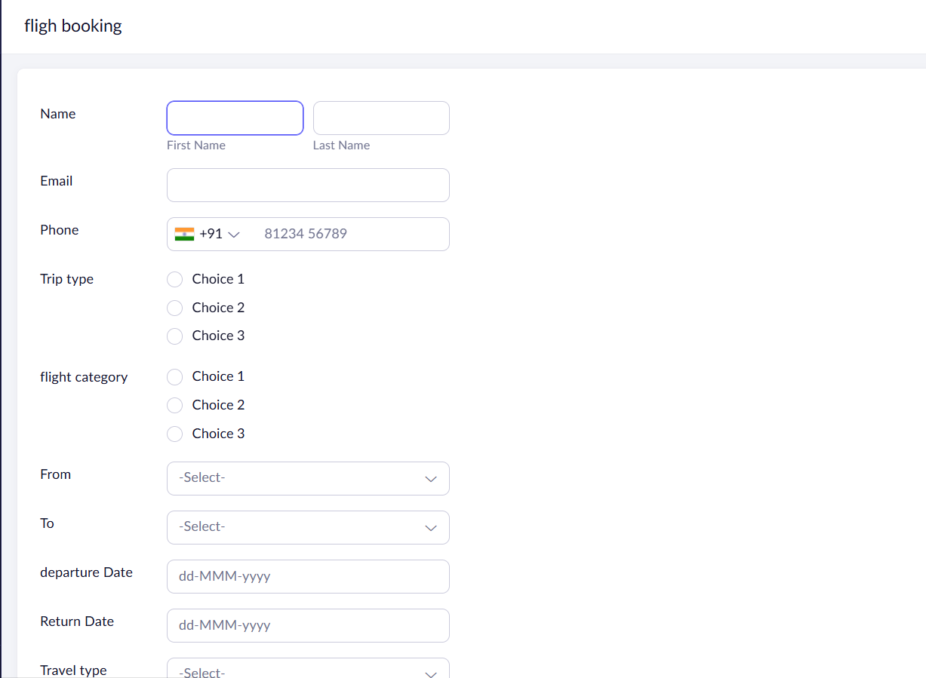
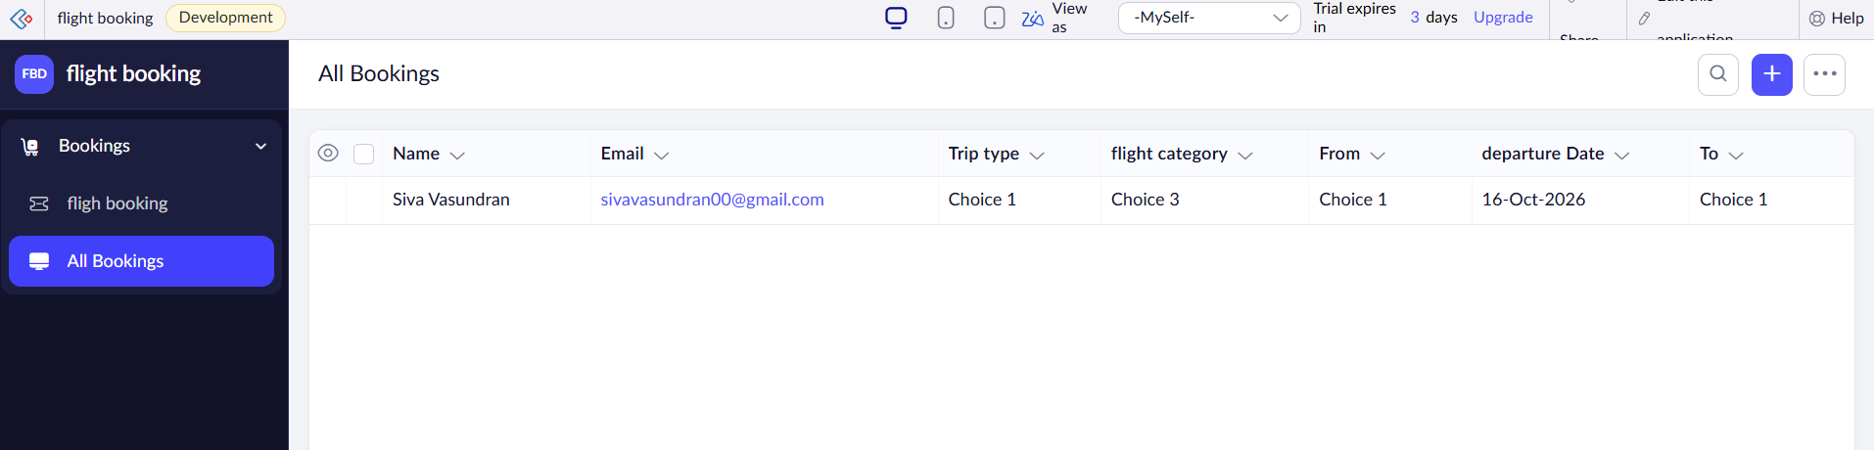

Result
Thus, a cloud-based Property Buying and Rental System was created successfully using Zoho Creator

